Day 7:
Final keyword :
- Final keyword we can use with variable, method and class.
- Final variable : to declare a constant value we use final keyword.
final int A=10; // const a=10; in JavaScript
- Final method : if method is final we can’t override that method.
- Final class : if class is final we can’t extends or inherits that class.

static keyword:
- Static keyword we can use with variable, method but not with class.
- Static variable: if variable is static we can access that variable with help of class name rather than object. Static variable also known as a class variable.
- Static method : if method is static we can access that method with help of class name. object not required.
- We can access or change the value of static variable with help of object also. Even though we can call static method with help of object name.
- Inside non static method we can access static as well as non static variable directly but inside static method we can access only static variable directly.

Instance or heap memory vs static memory
- Every class contains one static memory. It is only one copy. Numer of object creation of that class equal to number of heap memory means number of copies.
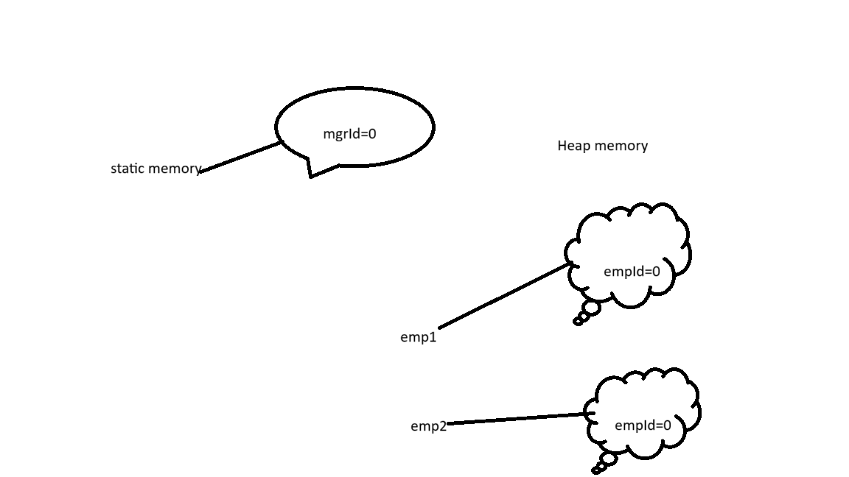

Static variable is global to all object(like common property for all objects).

interface: interface is type of reference data type. Also known as 100% pure abstract class.
Syntax to declare the interface.

interface interfaceName {
variables
methods;
}
By default all variable part of interface are public, static and final. Interface contains only constant variables.
By default all methods in interface are public and abstract. Interface contains only incomplete methods.

interface Abc {
public static final int A=10;
static final int B=20;
final int C=30;
int D=40;
public abstract void dis1();
abstract void dis2();
void dis3();
}

interface Abc {
int A=100;
void dis1();
}
interface Xyz {
int B=200;
void dis2();
}
interface Mno extends Abc,Xyz{
int C=300;
void dis3();
}
class Test implements Abc,Xyz {
need to provide the body for dis1() and dis2() mandatory.
}
Interface can extends more than one interface at time. But class can’t we can achieve multiple inheritance using interface not using class. Class always implements one or many interface. Which ever class implements any interface that class must be provide the body for all those method mandatory.

Abstract class Vs Interface.
- abstract class can contain normal as well as final variable. Interface contains only final variables.
- Abstract class can contain normal as well as abstract method. It can contain even normal method. Interface contain only abstract method.
- Normal class can extends only one abstract class. Normal class can implements more than one interface.
- Abstract class can contains default constructor as well as we can write user defined constructor. Interface no default constructor as well as we can’t write user defined constructor.
- Using abstract class we can achieve partial abstraction. Using interface we can achieve 100% abstraction.

Common between interface and abstract
- We can’t create the object of interface as well as abstract class.
- Which ever class implements or extends interface as well as abstract class that class must be provide the body for all abstract class.

